Theory

I2C in Arduino

1.1: I2C protocol overview

I2C, or Inter-Integrated Circuit, is a two-wire half-duplex serial communication interface developed by Philips Semiconductors (now NXP Semiconductors) in the 1980s. It is used to connect low-speed devices, such as sensors and microcontrollers, with each other or with higher-level devices such as controllers, memory chips, or other integrated circuits. The I2C protocol was designed to reduce the number of wires required to connect multiple devices and to allow simple and efficient communication between them.
Like UART communication, I2C only uses two wires to transmit data between devices:
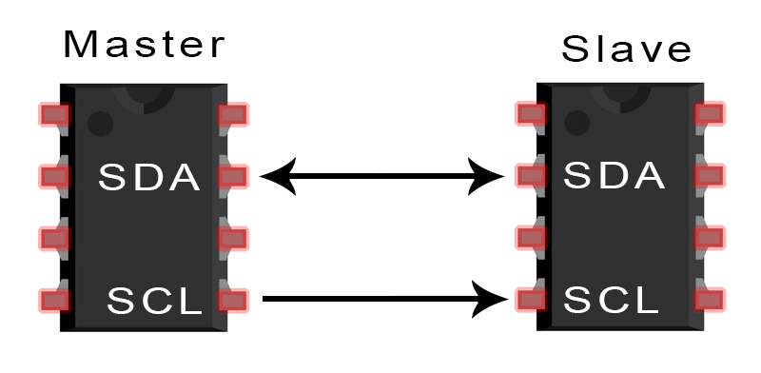
Figure 1: I2C protocol
SDA, the data line for master and slave communication, transfers bits serially. Along this single wire, information is conveyed from device to device.
SCL provides the clock, synchronizing the output and sampling of bits between devices on the bus. As director of timing, the clock signal remains under the master's control.
I2C uses a serial protocol, sending data one bit at a time along the SDA line. Like SPI, it works synchronously. Both systems rely on a jointly held clock signal to pace transmission and reception of bits between the master and any slaves addressed. Precise timing is enforced through the clock, with the master laying down the beat.

1.2: I2C data transfer and timing

1.2.1 Bit Transfer
For each clock pulse, a single data bit is transferred on the SDA line, and the data must remain stable when the SCL line is high to avoid any misinterpretation of data. Any changes on SDA when SCL is high are considered control signals like START or STOP conditions.
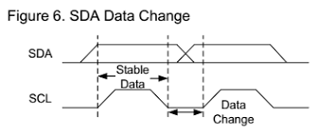
Figure 2: SDA Data Change

1.2.2 Start and stop conditions
All I2C transactions begin with a START (S) and are terminated by a STOP (P).
- START condition: When a HIGH to LOW transition occurs on the SDA line while SCL is HIGH.
- STOP condition: When a LOW to HIGH transition occurs on the SDA line while SCL is HIGH.
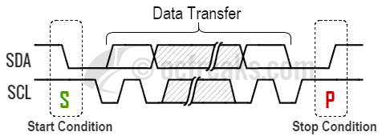
Figure 3: I2C Start and stop bits transfer

1.2.3 I2C Data Transfer
In the I2C data transmission protocol, the information is transmitted across the bus in packets of 8 bits normally referred to as bytes. After each of the bytes transmitted, an acknowledgement bit is returned to the checking of whether the slave device has successfully received data. All the data bits and the ACK bit required for the master device are generated. If the slave does not send an ACK, it means that either it is not ready or it has no further data to be transferred. Thus, the master must send a Stop condition to allow the bus release, or a Repeated Start condition in case it has further communications to make without releasing the bus. This arrangement ensures orderly data transfer and flow control at the I2C bus.
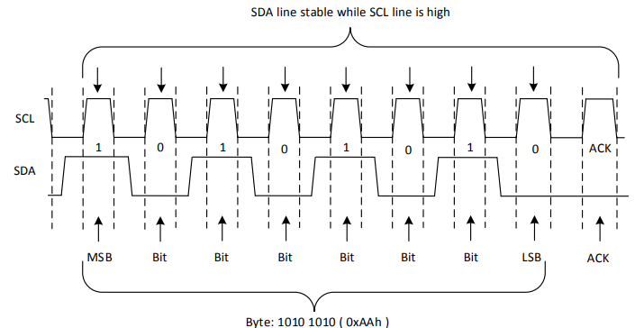
Figure 4: Example of Single Byte Data Transfer

1.2.4 I2C Synchronization
When there are multiple masters connected in an I2C bus, synchronization refers to the coordination of the clocks of all masters such that the data transfer proceeds properly. Though every master generates its own SCL signal, all the masters are observing the SCL line. If one of the masters pulls the clock line low, then it remains low until the other masters also release it. This is exactly how the masters can "stretch" the clock and share the lowest clock frequency. Once the clock is released, the SCL stays high until the first master pulls it low again.

1.2.5 Arbitration
Even though multiple masters may be present on the I2C bus the arbitration is handled in such a way that there is no corruption of data on bus in case when more than 2 masters try to transmit data at the same time. Since the transmission, synchronization and arbitration is done using only 2 wires on the bus, the communication protocol might be a bit uneasy to understand for beginners ... but it’s actually easy to understand.

1.2.6 Communication with 7-BIT I2C Addresses
In 7-bit I2C addressing, communication starts with the master issuing a START condition, followed by the 7-bit address of the slave and a read/write (R/W) bit. The slave acknowledges by pulling the SDA line low, allowing data transfer to proceed in 8-bit bytes with an ACK bit after each. The master ends communication with a STOP or repeated START condition. For switching from write to read, a repeated START is used with the read bit set. This flexible approach enables communication with multiple devices on the same bus.

1.3: LM75B temperature sensor
LM75 Temperature Sensor module is a delta-sigma analog to digital converter. The cost-effective device consumes less power and is highly precise. An over-temperature protection circuit is integrated to sink the current that shut down in the module in case of over the limit temperature. LM75 communicates the data using the I2C interface. To connect multiple hosts to the same bus, three address pins are available for the purpose.
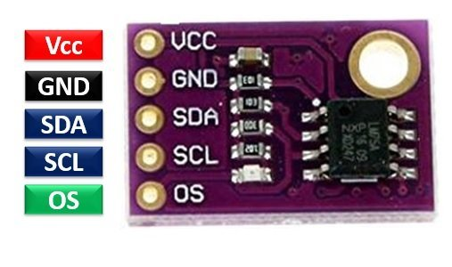
Figure 5: LM75B temperature sensor

Procedure

Part 2.1: Writing the LCD to Arduino and I2C scanning
The LCD was connected to the Arduino using the 5V, GND, SDA, and SCL pins as shown in the below figure.
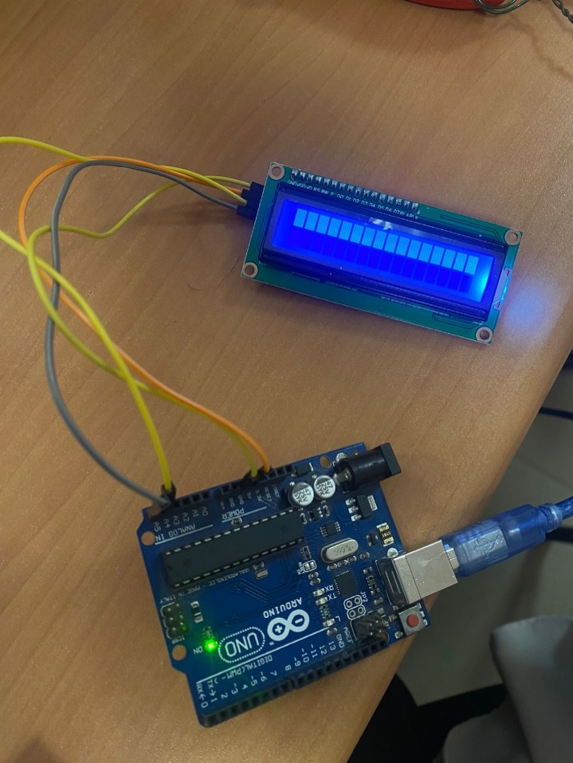
Figure 6: Find the address connection
After uploading the code provided in the appendix, the connection was successful, and the output was displayed on the serial monitor as follow:
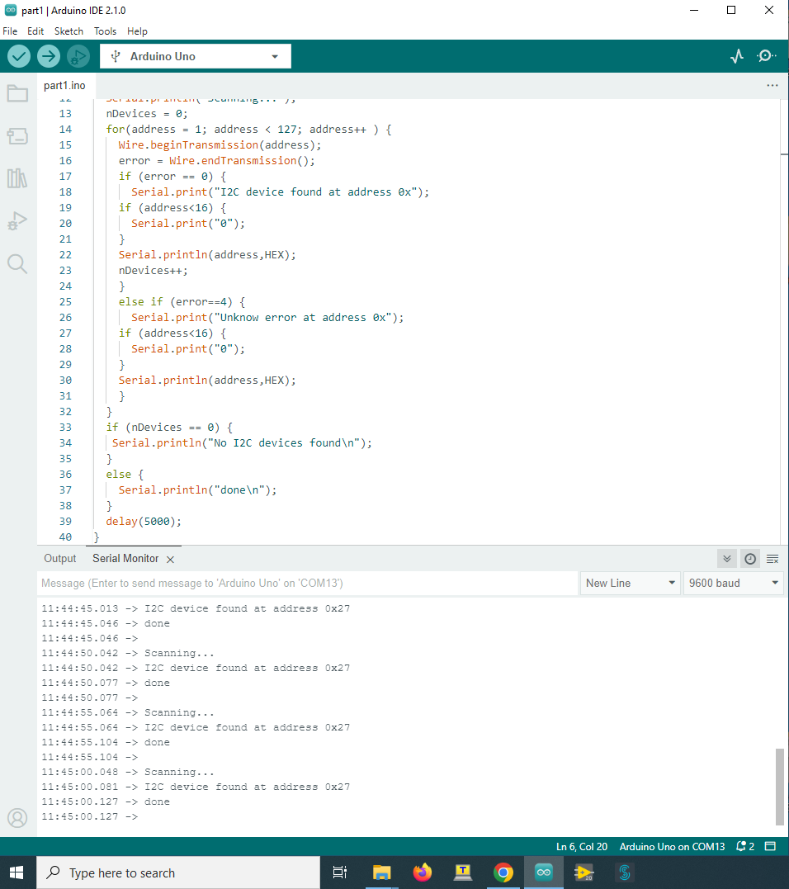
Figure 7: Serial Monitor output for address
We will utilize address 0x27, which was the LCD's unique address while using the I2C, in the coming sections.

Part 2.2: Display static text on the LCD
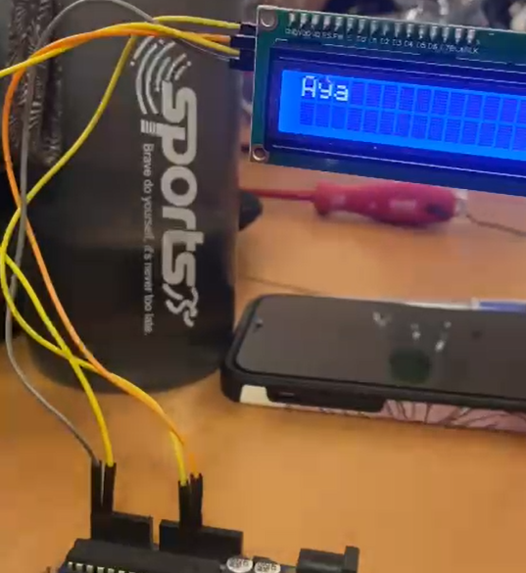
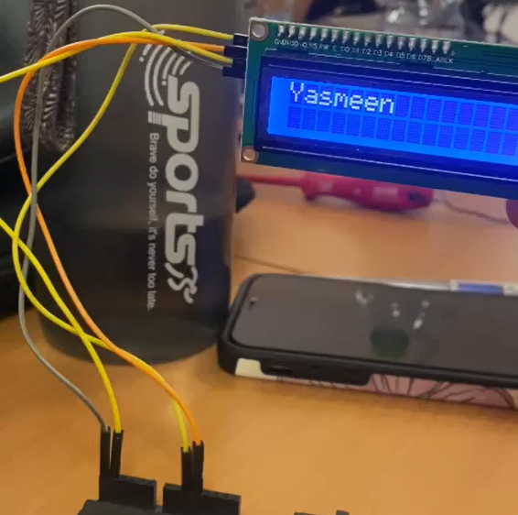
After configuring the LCD address to 0x27, the provided code was uploaded to the Arduino. The code was designed to display each name on the LCD, one at a time, with a delay between each change. This allowed for static text to be shown on the screen, transitioning between different names sequentially.

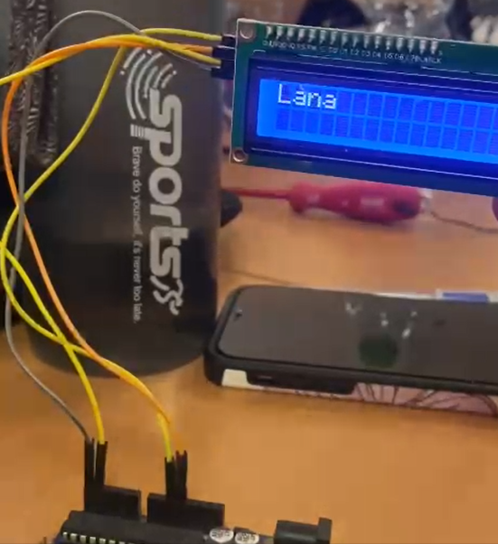

Part 2.3: I2C communication between 2 Arduinos
The implementation of I2C communication was done between two Arduinos: one as a master and the other as a slave. We connected the devices according to the schematic shown in the figure below, making sure the GND is common.
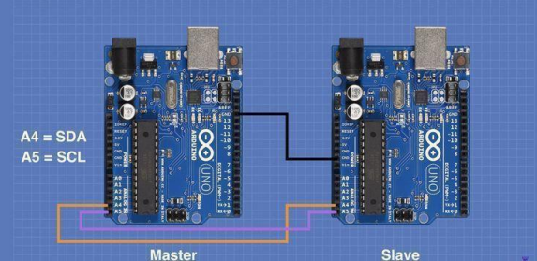
Figure 8: I2C communication between 2 Arduinos connection
Programmed the master to receive data from the slave; the slave transmitted sequentially character from '0' to 'z'. Having uploaded the respective master and slave codes in each Arduino, we started the serial monitor of the master unit and observed that the characters were received sequentially, thereby confirming us that the I2C communication is working as expected as follows:
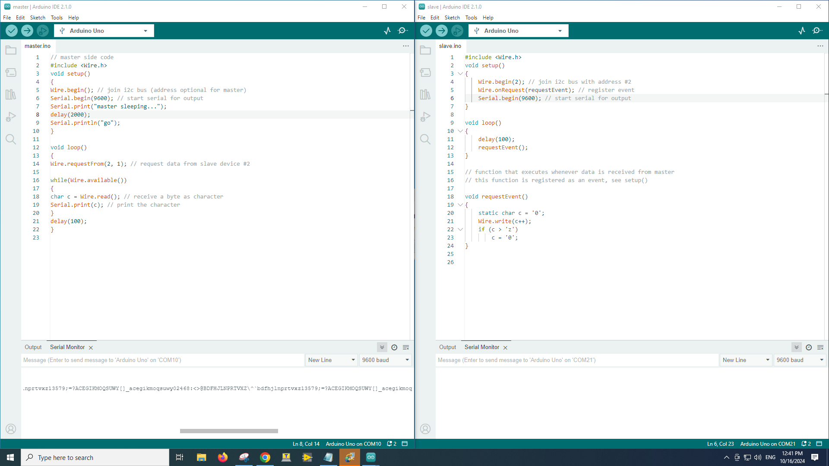
Figure 9: I2C communication between 2 Arduinos master receiving

Part 2.4: I2C communication between 2 Arduinos and LCD

We provided communication between two Arduino devices using the I2C protocol and displayed analog readings from a potentiometer using an LCD connected to the master Arduino. From the previous section, we checked that the I2C connections were correctly set. An LCD was connected to the SDA and SCL pins from the master Arduino, while a potentiometer was attached to the A0 pin on the slave Arduino as shown in the figure:
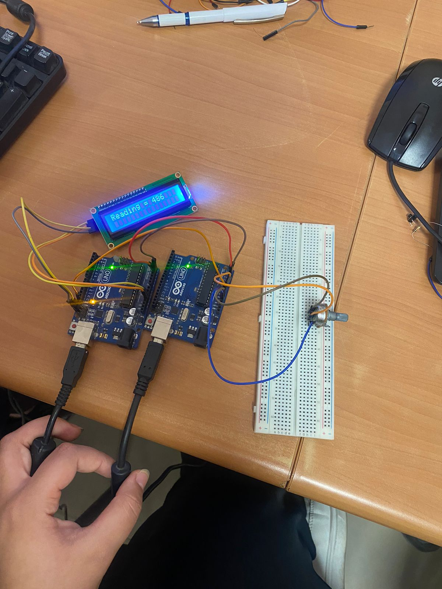
Figure 10: I2C communication between 2 Arduinos and LCD connection

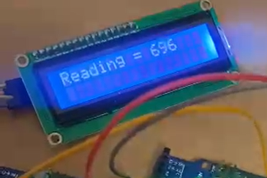
After uploading the master and slave codes, the master read the analog values transmitted by the slave and displayed them on the LCD. The serial monitor gave confirmation of the data in transmission.
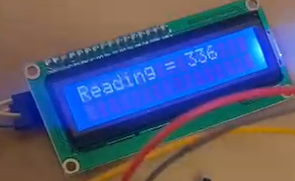
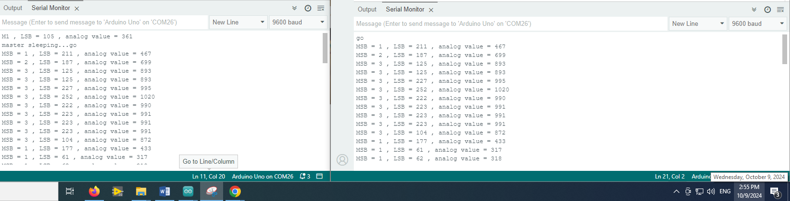
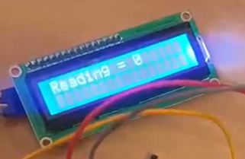
Figure 11: I2C communication between 2 Arduinos and LCD serial monitor & LCD output

Part 2.5: I2C communication between Arduino and Temperature sensor (LM75B)

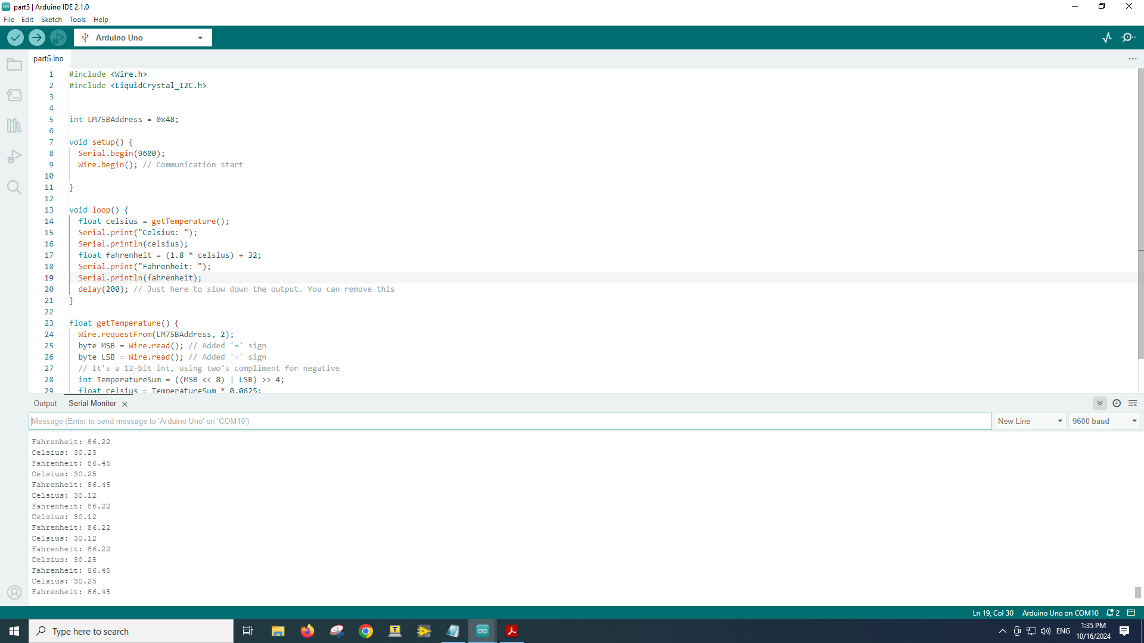
The LM75B temperature sensor was interfaced with the Arduino via I2C to measure the temperature, and the readings were displayed on the serial monitor, demonstrating the results as shown.
Figure 12: I2C communication between Arduino and Temperature sensor connection and serial monitor output
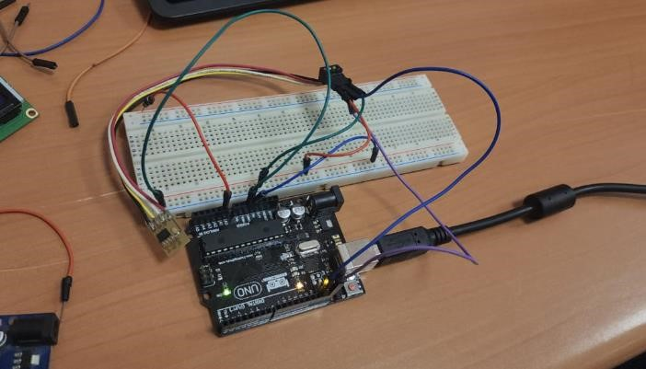
This Arduino code connects to an LM75B temperature sensor using the I2C protocol, assigning the sensor's address to 0x48.

ToDo

In this todo, an Arduino, an LCD, and a temperature sensor (LM75B) were used, the master writes on the LCD, while the slave reads from the sensor. The codes for the master and slave are included in the Appendix. The connection is shown in the figure below:
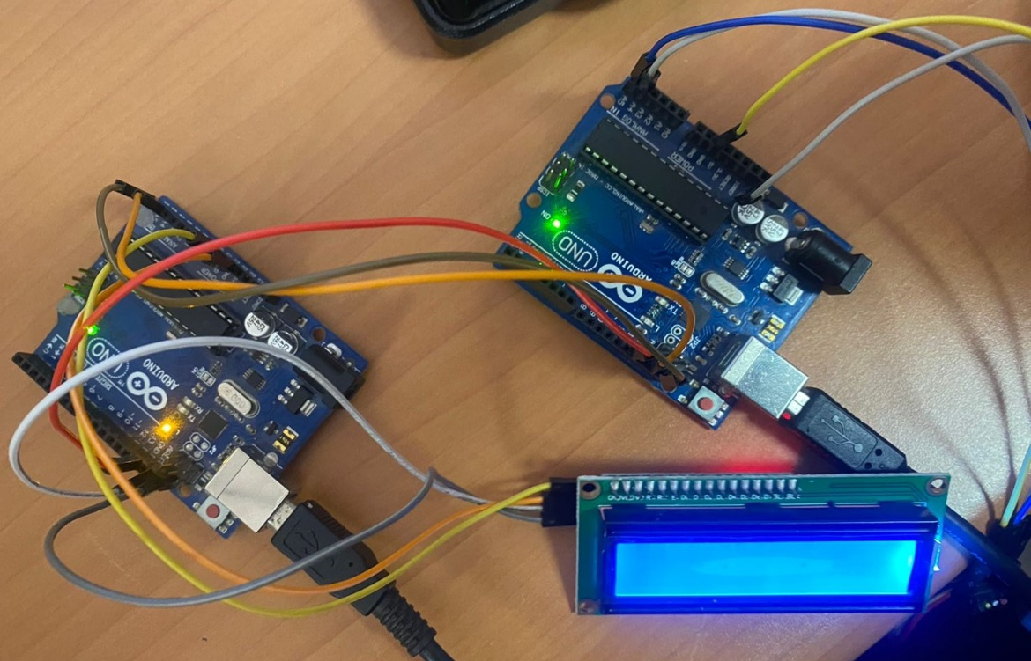
Figure 13: ToDo connection
Unfortunately, we were unable to fully execute this part because we waited for the temperature sensor to be available. After getting it, we didn't have enough time, like the rest of the students, to apply it correctly, but this is what we were able to achieve, and despite our understanding of how they operate

Conclusion
Throughout this experiment, we successfully demonstrated several scenarios of the I2C communication, which included connecting two Arduinos and also connecting an LM75B temperature sensor with one Arduino. This included the approach of reading data from sensors, sending that data over I2C, and displaying that results using an LCD or a serial monitor.

Refrences
https://www.circuitbasics.com/basics-of-the-i2c-communication-protocol/
https://embeddedwala.com/Blogs/DigitalCommunication/Getting-Started-with-I2C:-A-Beginners-Guide
https://www.ti.com/lit/an/slva704/slva704.pdf
https://www.ocfreaks.com/i2c-tutorial/
https://www.design-reuse.com/articles/54776/i2c-interface-timing-specifications-and-constraints.html

Appendixes

Part 1:
#include <Wire.h>
#include <LiquidCrystal_I2C.h>

void setup() {
Wire.begin();
Serial.begin(9600);
Serial.println("\nI2C Scanner");
}
void loop() {
byte error, address;
int nDevices;
Serial.println("Scanning...");
nDevices = 0;
for(address = 1; address < 127; address++ ) {
Wire.beginTransmission(address);
error = Wire.endTransmission();
if (error == 0) {
Serial.print("I2C device found at address 0x");
if (address<16) {
Serial.print("0");
}
Serial.println(address,HEX);
nDevices++;
}
else if (error==4) {
Serial.print("Unknow error at address 0x");
if (address<16) {
Serial.print("0");
}
Serial.println(address,HEX);
}
}
if (nDevices == 0) {
Serial.println("No I2C devices found\n");
}
else {
Serial.println("done\n");
}
delay(5000);
}

Part 2
#include <LiquidCrystal_I2C.h>

// set the LCD number of columns and rows
int lcdColumns = 16;
int lcdRows = 2;
// set LCD address, number of columns and rows
// if you don't know your display address, run an I2C scanner sketch
LiquidCrystal_I2C lcd(0x27, lcdColumns, lcdRows);
void setup() {
// initialize LCD
lcd.init();
// turn on LCD backlight
lcd.backlight();
}
void loop() {
// set cursor to first column, first row
lcd.setCursor(0, 0);
// print message
lcd.print("Aya");
delay(1000);
// clears the display to print new message
lcd.clear();

lcd.print("Lana");
delay(1000);
lcd.clear();

lcd.print("Yasmeen");
delay(1000);
lcd.clear();
}

Part 3

Master
#include <Wire.h>
void setup()
{
Wire.begin(); // join i2c bus (address optional for master)
Serial.begin(9600); // start serial for output
Serial.print("master sleeping...");
delay(2000);
Serial.println("go");
}
void loop()
{
Wire.requestFrom(2, 1);
while(Wire.available())
{
char c = Wire.read(); // receive a byte as character
Serial.print(c); // print the character
}
delay(100);
}

Slave
#include <Wire.h>
void setup()
{
Wire.begin(2);
Wire.onRequest(requestEvent); // register event
Serial.begin(9600); // start serial for output
}

void loop(){
delay(100);
}

void requestEvent(){
static char c = '0';
Wire.write(c++);
if (c > 'z')
c = '0';
}

Part 4

Master
#include <Wire.h>
#include <LiquidCrystal_I2C.h>
// set the LCD number of columns and rows
int lcdColumns = 16;
int lcdRows = 2;
// set LCD address, number of columns and rows
// if you don't know your display address, run an I2C scanner sketch
LiquidCrystal_I2C lcd(0x27, lcdColumns, lcdRows);
void setup()
{
Wire.begin();
// join i2c bus (address optional formaster)
Serial.begin(9600); // start serial for output
Serial.print("master sleeping...");
delay(2000);
Serial.println("go");
// initialize LCD
lcd.init();
// turn on LCD backlight
lcd.backlight();
}

void loop()
{
Wire.requestFrom(50, 2);
// request data from slave device
int res;//result from I2c reading
byte MSB = Wire.read(); /* receive a byte MSB(NOTE: the function is blocking, so it would not continue the code until a byte reach)*/
byte LSB = Wire.read(); /* receive a byte LSB(NOTE: the function is blocking, so it would not continue the code until a byte reach)*/
res = ((MSB << 8) | LSB);
Serial.print("MSB = ");
Serial.print(MSB);
Serial.print(" , LSB = ");
Serial.print(LSB);
Serial.print(" , analog value = ");
Serial.println(res); // print the analog value
// set cursor to first column, first row
lcd.setCursor(0, 0);
// print message
lcd.print("Reading = ");
lcd.print(res);
delay(1000);
lcd.clear();
}

Slave
#include <Wire.h>
void setup()
{
Wire.begin(50);// join i2c bus with address #2
Wire.onRequest(requestEvent); // register event
Serial.begin(9600); // start serial for output
}
void loop()
{
delay(100);
}
// function that executes whenever data is received from master
// this function is registered as an event, see setup()

void requestEvent()
{
int value = analogRead(A0);
Wire.write(value >> 8); // send the MSB
Wire.write(value & 0x00ff); // send the LSB
}

Part 5
#include <Wire.h>
#include <LiquidCrystal_I2C.h>

int LM75BAddress = 0x48;

void setup() {
Serial.begin(9600);
Wire.begin(); // Communication start

}

void loop() {
float celsius = getTemperature();
Serial.print("Celsius: ");
Serial.println(celsius);
float fahrenheit = (1.8 * celsius) + 32;
Serial.print("Fahrenheit: ");
Serial.println(fahrenheit);
delay(200); // Just here to slow down the output. You can remove this
}

float getTemperature() {
Wire.requestFrom(LM75BAddress, 2);
byte MSB = Wire.read(); // Added '=' sign
byte LSB = Wire.read(); // Added '=' sign
// It's a 12-bit int, using two's compliment for negative
int TemperatureSum = ((MSB << 8) | LSB) >> 4;
float celsius = TemperatureSum * 0.0625;
return celsius;
}

ToDo

Master
#include <Wire.h>
#include <LiquidCrystal_I2C.h>

// set the LCD number of columns and rows
int lcdColumns = 16;
int lcdRows = 2;

// set LCD address, number of columns and rows
LiquidCrystal_I2C lcd(0x27, lcdColumns, lcdRows);

void setup()
{
Wire.begin(); // join i2c bus
Serial.begin(9600); // start serial for output
Serial.print("master sleeping...");
delay(2000);
Serial.println("go");
// initialize LCD
lcd.init();
// turn on LCD backlight
lcd.backlight();

}

void loop()
{
Wire.requestFrom(50, 2); // request data from slave device
delay(2000); // Adjust delay as needed
int res;
}

void getTemperature() {
Wire.requestFrom(LM75BAddress, 2);
byte MSB = Wire.read();
byte LSB = Wire.read();

int res = ((MSB << 8)| LSB;
lcd.setCursor(0, 0);
// print
lcd.print("Temp = ");
lcd.print(res);
delay(1000);
lcd.clear();

}

Slave
#include <Wire.h>
#include <LiquidCrystal_I2C.h>

int LM75BAddress = 0x48;

void setup()
{
Wire.begin(50);
Wire.onRequest(requestEvent); // register event
Serial.begin(9600); // start serial for output

}

void loop()
{
getTemperature();
delay(2000);
}

void requestEvent()
{
int value = analogRead(A0);
Wire.write(value >> 8); // send the MSB
Wire.write(value & 0x00ff); // send the LSB
}

